**How to Update the Firmware of APX-8000**

Step 1: Save the file "APX-8000 Firmware upgrade tool.zip" and the file "apx-8000 firmware V1.0.bin" to your computer, and then unzip the file "APX-8000 Firmware upgrade tool.zip".  
  
Step 2: Make sure the main unit APX-8000 is powered off. Connect the main unit to a computer by a programming cable for APX-8000. Press and hold the transmit button (PTT2) on the right side of the main unit to turn it on. A prompt of "Updata" will appear on the screen.

Step 3: Open the decompressed "APX-8000 Firmware upgrade tool.exe" and select the correct port as shown in the following figure:

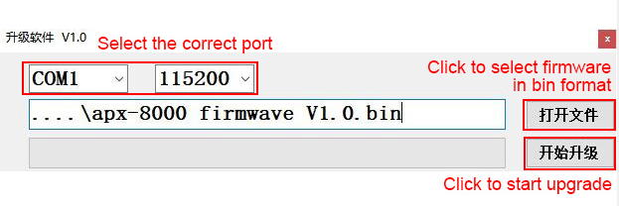

After selecting the port, click to open the file, find "apx-8000 firmware V1.0.bin" and load it, then click to start upgrade, and the upgrade progress bar will appear. Wait for the upgrade to complete.

